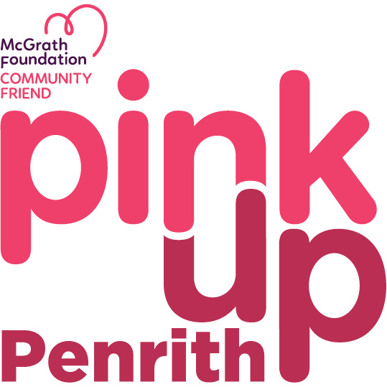
Registration Form

rego no
Proudly supporting all suburbs in the Penrith LGA
“Together we Will Make A Difference”
Help us do our part to make sure McGrath Breast Care Nurses are available to anyone who needs one in Nepean by donating to our town’s page today or by getting involved and planning your own activity using the details below:

Email your form to beth@penrithcbdcorp.com.au or drop it in to the CBD office 3/488 High St Penrith to complete your registration:

Business/Group /Individual Name: ________________________________________________
Contact Name: _______________________________________________________________
Address: _______________________________________________________________
Phone number: ______________________________________________________________
Email: ______________________________________________________________________

Option A: Fundraising information: Event or Initiative – Hold a function on behalf of Pink Up Penrith. Enter information below: (if not enough space please attach your details)
DATE
TIME
LOCATION
DESCRIPTION: (we recommend you attach your business logo or image of the event details/invite so we can include it on community event calendar)

Option B: Donation only: Can’t Pink Up but want to help? Register a donation in the dedicated Pink Up Penrith page on the McGrath Foundation website:
https://www.pinkisthecolour.com.au/fundraisers/wwwpinkuppenrithcomau/pink-up-penrith

Donation amount: $___________________
Bank Details once you have fundraised:
Please quote in the reference your P.U.P no.
Bank Name: nab
Account Name: Pink Up Penrith
BSB: 082-356
Account Number: 367213758
Thank you for your support and registration. Once you return the form to beth@penrithcbdcorp.com.au or drop it in to the Penrith CBD office 3/488 High St we will contact you with your registration number and confirm your details above.
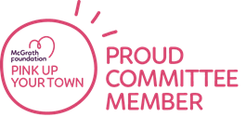
Regards,
Gai Hawthorn
4722 5556 (office hrs)

